Consider a Library Management System. Develop a JavaScript program that will validate the controls in the forms you have created for the application. State the assumptions you make (business logic you are taking into consideration).

Aim:
To develop a web-based Library Management System that validates user inputs using JavaScript and connects to a database using Servlets and JSP, while also demonstrating a simple Weather Information Webpage UI.

Procedure:
  - Create an HTML webpage for Library Management System.
  - Design a form to add books/users.
  - Apply JavaScript validation for all fields.
  - Create a JSP page to display data.
  - Develop a Servlet to handle form submission.
  - Connect the application to a MySQL database.
  - Insert validated data into the database.
  - Run the project on a server (e.g., Apache Tomcat).
  - Display success or error messages.

Code:

index.html
<!DOCTYPE html>
<html>
<head>
<title>Music Form</title>
<script>
function validateForm() {
let name = document.forms["f"]["name"].value;
let email = document.forms["f"]["email"].value;
let phone = document.forms["f"]["phone"].value;
let song = document.forms["f"]["song"].value;
if(name=="" || email=="" || phone=="" || song==""){
alert("All fields required");
return false;
}
if(phone.length!=10 || isNaN(phone)){
alert("Phone must be 10 digits");
return false;
}
return true;
}
</script>
</head>
<body style="text-align:center;font-family:Arial">
<h2> Music Form</h2>
<form name="f" action="MusicServlet" method="post" onsubmit="return validateForm()">
<input type="text" name="name" placeholder="Name"><br><br>
<input type="text" name="email" placeholder="Email"><br><br>
<input type="text" name="phone" placeholder="Phone"><br><br>
<input type="text" name="song" placeholder="Song"><br><br>
<select name="genre">
<option>Pop</option>
<option>Rock</option>
</select><br><br>
<input type="submit" value="Submit">
</form>
</body>
</html>

MusicServlet.java
import java.io.*;
import javax.servlet.*;
import javax.servlet.http.*;
import java.sql.*;
public class MusicServlet extends HttpServlet {
private static final long serialVersionUID = 1L;
public void doPost(HttpServletRequest req, HttpServletResponse res)
throws IOException {
String name = req.getParameter("name");
String email = req.getParameter("email");
String phone = req.getParameter("phone");
String song = req.getParameter("song");
String genre = req.getParameter("genre");
res.setContentType("text/html");
PrintWriter out = res.getWriter();
try {
Class.forName("com.mysql.cj.jdbc.Driver");
Connection con = DriverManager.getConnection(
"jdbc:mysql://localhost:3306/musicdb","root","password");
PreparedStatement ps = con.prepareStatement(
"insert into users values(?,?,?,?,?)");
ps.setString(1,name);
ps.setString(2,email);
ps.setString(3,phone);
ps.setString(4,song);
ps.setString(5,genre);
int i = ps.executeUpdate();
if(i>0){
//  REDIRECT FIX
res.sendRedirect("display.jsp");
} else {
out.println("Error inserting");
}
} catch(Exception e){
out.println(e);
}
}
}
display.jsp
<%@ page import="java.sql.*" %>
<html>
<head>
<title>Music Records</title>
<style>
body {
margin: 0;
font-family: Arial;
background: linear-gradient(135deg, #1db954, #191414);
color: white;
}
.container {
width: 80%;
margin: 50px auto;
background: #121212;
padding: 30px;
border-radius: 15px;
box-shadow: 0 0 20px rgba(0,0,0,0.6);
text-align: center;
}
h2 {
color: #1db954;
}
table {
width: 100%;
border-collapse: collapse;
margin-top: 20px;
}
th {
background: #1db954;
padding: 12px;
}
td {
padding: 10px;
border-bottom: 1px solid #333;
}
tr:hover {
background: #1e1e1e;
}
a {
text-decoration: none;
}
button {
margin-top: 20px;
padding: 10px 20px;
background: #1db954;
border: none;
border-radius: 20px;
color: white;
cursor: pointer;
}
button:hover {
background: #1ed760;
}
</style>
</head>
<body>
<div class="container">
<h2> Music Records</h2>
<table>
<tr>
<th>Name</th>
<th>Email</th>
<th>Phone</th>
<th>Song</th>
<th>Genre</th>
</tr>
<%
try{
Class.forName("com.mysql.cj.jdbc.Driver");
Connection con = DriverManager.getConnection(
"jdbc:mysql://localhost:3306/musicdb","root","YOUR_PASSWORD");
Statement stmt = con.createStatement();
ResultSet rs = stmt.executeQuery("select * from users");
while(rs.next()){
%>
<tr>
<td><%=rs.getString(1)%></td>
<td><%=rs.getString(2)%></td>
<td><%=rs.getString(3)%></td>
<td><%=rs.getString(4)%></td>
<td><%=rs.getString(5)%></td>
</tr>
<%
}
}catch(Exception e){
out.println("<p style='color:red;'>"+e+"</p>");
}
%>
</table>
<a href="index.html">
<button>⬅ Go Back</button>
</a>
</div>
</body>
</html>

web.xml

<web-app>
<welcome-file-list>
<welcome-file>index.html</welcome-file>
</welcome-file-list>
<servlet>
<servlet-name>MusicServlet</servlet-name>
<servlet-class>MusicServlet</servlet-class>
</servlet>
<servlet-mapping>
<servlet-name>MusicServlet</servlet-name>
<url-pattern>/MusicServlet</url-pattern>
</servlet-mapping>
</web-app>

Output:

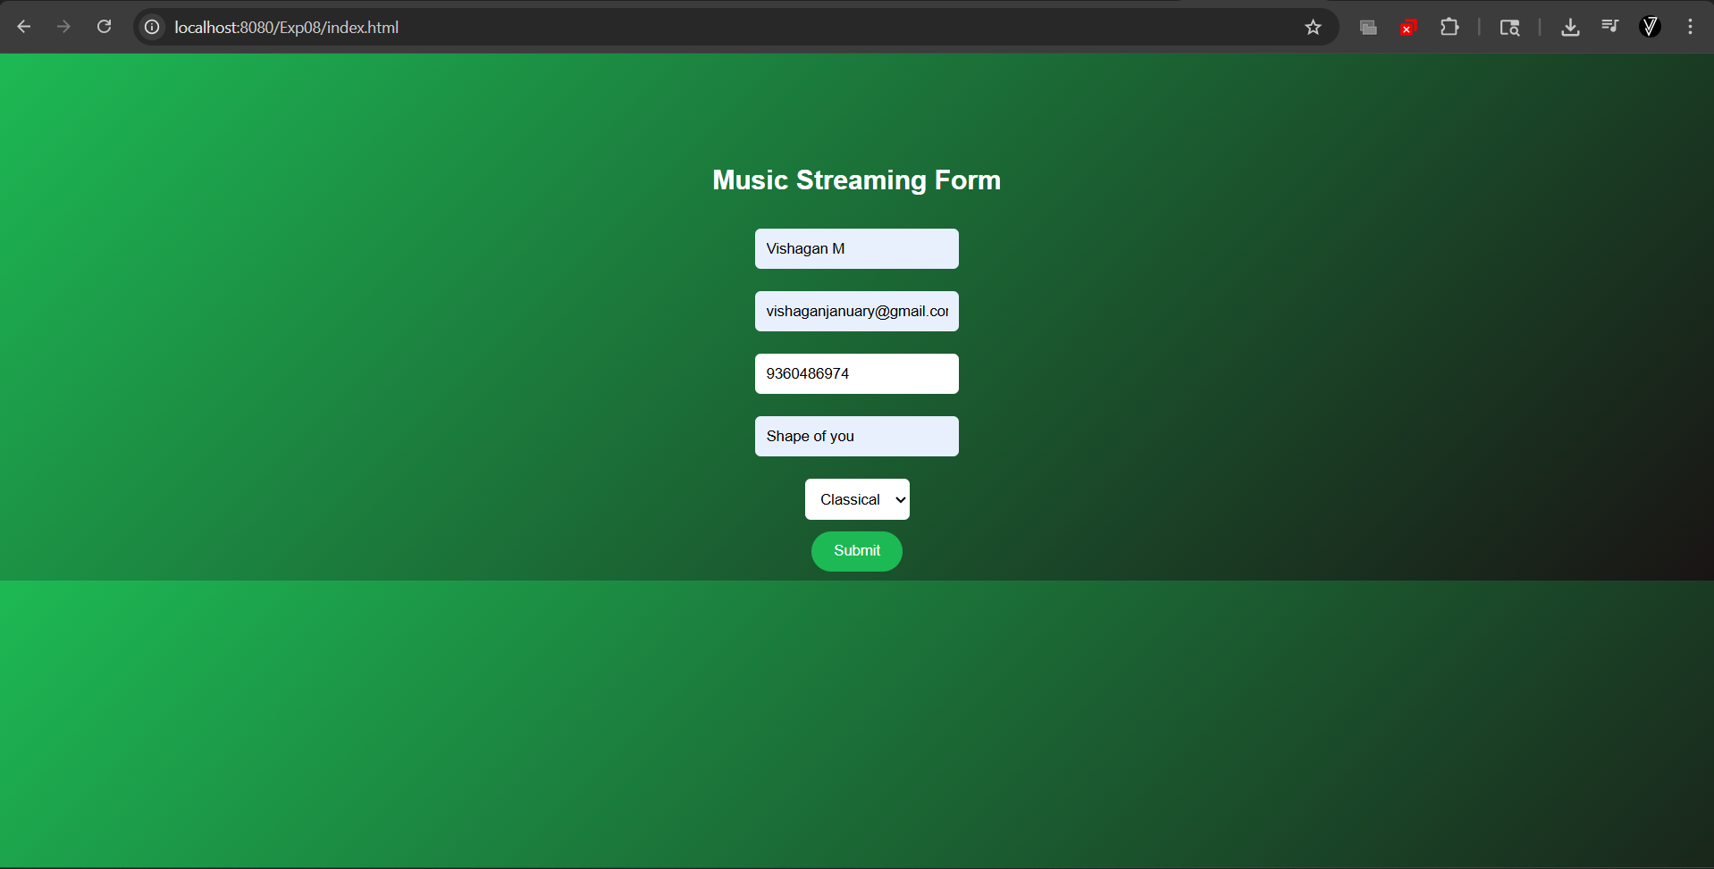

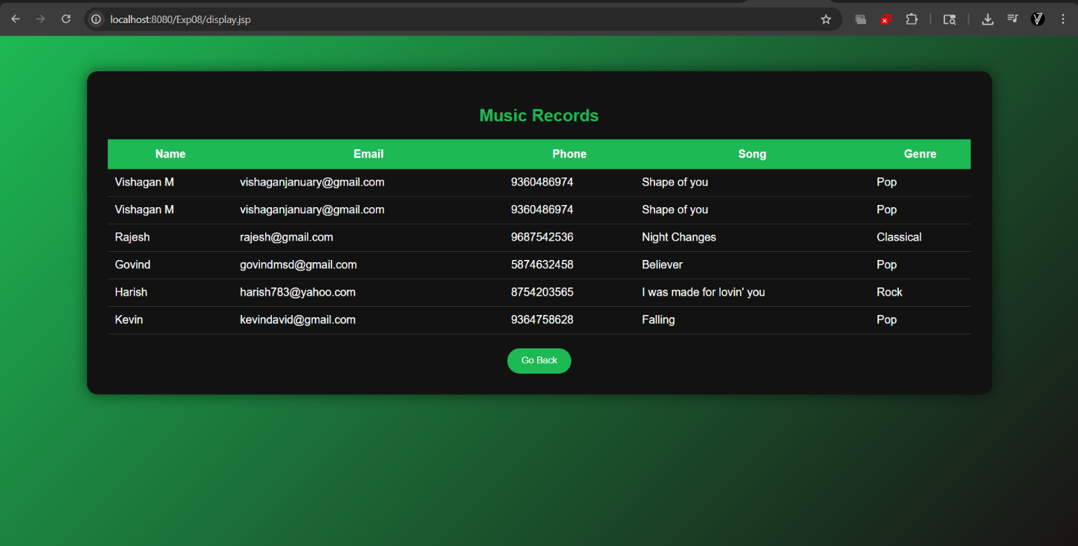

Result:
Thus, the Library Management System with JavaScript validation and database connectivity using Servlet and JSP was successfully developed and executed.

